**2019 Semester 1, Year 11 Unit 1 Economics Examination**

**Section 1 – Multiple Choice**

|  |  |  |  |
| --- | --- | --- | --- |
| **1** | **D** | **13** | **A** |
| **2** | **B** | **14** | **D** |
| **3** | **C** | **15** | **B** |
| **4** | **A** | **16** | **B** |
| **5** | **D** | **17** | **C** |
| **6** | **A** | **18** | **A** |
| **7** | **A** | **19** | **C** |
| **8** | **C** | **20** | **A** |
| **9** | **B** | **21** | **B** |
| **10** | **D** | **22** | **A** |
| **11** | **A** | **23** | **D** |
| **12** | **B** | **24** | **A** |

**Section 2 – Data Interpretation**

**Question 25 (a) (2m)**

1. 6 x 4m = 24m (1m)
2. 2.5 x 4m = 10m (1m)

**Question 25 (b)**  **(4m)**

1. Diagram (accurate – second mark is the shift of Demand C) (2m)
2. Impact on equilibrium price (1m)
3. Impact on equilibrium qty (1m)
4. DD factor (taste and preference for 4th mark.) (1m)

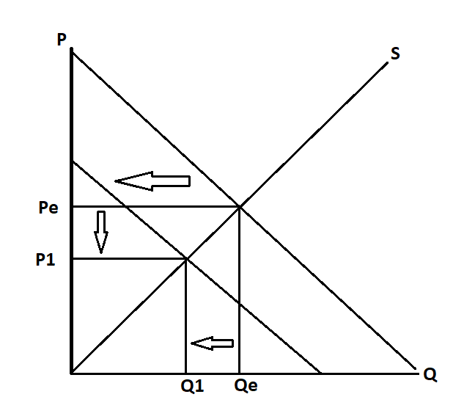P reduced, Q reduced

**Question 25 (c) (6m)**

1. ***At least 3 Supply factors to be identified***
2. *Identify factor (1m) x 3*
3. *Explain factor within context (1m) x 3*

Eg.

1. Cost of production
2. Technology
3. Government policy
4. Expectations (market)
5. Change in size of market

Number of growers, weather, technology, other factors of production costs

**Question 26 (a) (2m)**

1. Define opportunity cost - next best alternative forgone (1m)
2. *Eg. Govt Expenditure on –* Hospitals, Schools, Roads, etc. (1m)

**Question 26 (b) (6m)**

1. Diagram (accurate and sufficiently referred to) (2m)
2. Impact on **efficiency**

* Highlight change in CS and PS (Total Surplus) (1m)
* Deadweight Loss highlights inefficiency (1m)

1. Impact on **equity**

* lower prices - greater affordability (1m)
* more lower income groups have access – improves horizontal equity (1m)



**Question 26 (c) (4m)**

1. ***Identify Policy x 2*** *(1m) x 2*
2. *Policies – Subsidies, Public housing*, progressive Taxes (redistributive), Improved access to education, price floors, etc
3. ***Explanation:*** *(1m) x 2*

*Explanation must link to improvement in welfare of lower SES grps*

*Market based measures should highlight link to impact on market (P & Q)*

**E.g.**

1. **Subsidies**  (1m)

Explanation (1m)

* + Lowers cost of production; reduces equilibrium price rendering good/service more affordable. Lower income groups enjoy greater access due to improved affordability.

1. **Build public housing**  (1m)

Explanation (1m)

* + Increase in supply of public housing, lowers price of housing due to increased supply reduces rental rates due to greater availability. Improves affordability.

**Note:** *If Price ceiling is included in the response only a 1-mark maximum is awarded. This is due to repetition with Qn. 26 (b)*

**Question 27 (a) (2m)**

Atmosphere – Explain in terms of rivalry and excludability

1. Rival in consumption – use degrades breathable air (1m)
2. Non-excludable – costly to exclude users in obtaining benefits from its use (1m)

**Question 27 (b) (2m)**

Explanation - Explain in terms of rivalry and excludability

1. **Non- excludability** leads to overuse and because usage is **rivalrous** it leads to degradation of common property resource for which no appropriate compensation is paid (1m)
2. **3rd party effect** -> Poor atmosphere -> asthma, lung disease, etc. (1m)

**Question 27 (c) (4m)**

1. Diagram (accurate and sufficiently referred to) (1m)
2. Marginal External Cost (MEC) not taken into account (1m)
3. **Overproduction** highlighted – Overallocation of resources (1m)
4. Deadweight loss (misallocation of resources) linked to inefficiency (1m)

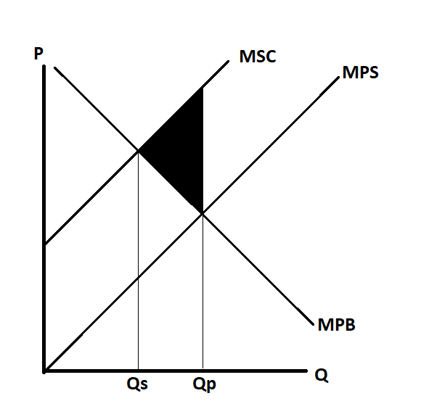

**Question 27 (d) (4m)**

1. **Identify policy x 2** (1m) x 2

**Policy options** - Pigouvian tax, Regulation, Education, Advertising, etc.

1. **Explanation:** (1m) x 2

Market-based measures (like taxes) should highlight **internalisation** of cost

Must link to reduction of externality (effect on 3rd party) – If not linked for both policy options a maximum of 1 mark deducted.